Debate or knife fight? Bevin hurls attacks at Beshear in KY gubernatorial debate.
BY DANIEL DESROCHERS
OCTOBER 15, 2019 09:45 PM

Kentucky Gov. Matt Bevin, Republican candidate for governor, left, and Kentucky Attorney General Andy Beshear, Democratic candidate for Kentucky governor, participate in a debate at the Singletary Center for the Arts on the University of Kentucky campus in Lexington, Ky., Tuesday, Oct. 15, 2019.
The relationship between Gov. Matt Bevin and Attorney General Andy Beshear has dripped with animosity for three and a half years. On Tuesday night, it poured onto the debate stage.
Less than five minutes into their second gubernatorial debate, held at the University of Kentucky’s Singletary Center for the Arts, Bevin threw an insult as Beshear tied the governor to an unpopular pension overhaul bill passed by the Republican-led General Assembly.
“Legislators are the ones who pass bills,” Bevin said “They decide what gets stuck in what. Your complete incompetence as it relates to understanding the legislative process is a little concerning for a guy who wants to be the governor.”
It only got nastier from there.
Beshear has often been criticized as a “talking point politician” who rarely deviates from a script while campaigning. That trait became his biggest liability on stage with Bevin as the governor came ready to pounce.
Beshear tossed out a line about how his father and grandfather grew up poor.
“If you have to brag about how poor your father and grandfather were, that’s a bit of a stretch,” Bevin said.
Beshear said he respected teachers so much that he made one his running mate.
“You love public education so much that your kids go to private school,” Bevin said.
After Beshear accused Bevin of attacking his children, Bevin retorted: “I’m just saying you’re a fraud.”
It continued for an hour. The debate touched on all the major issues of the campaign — the pension crisis, the economy, health care, and education.
It laid out stark differences between the candidates on several issues, including abortion (Beshear pointed out that Bevin believes abortion should be illegal even in cases of rape or incest), medicinal marijuana (Bevin pointed out that Beshear thinks medical marijuana should be taxed even though it’s medicine), health care (Bevin believes in work requirements for able-bodied people who are eligible for Medicaid), and jobs (Bevin pointed to growth in the economy, Beshear said gains have bypassed rural Kentucky).
But much of the substance was overshadowed by the two candidates laying into each other.
In one of the rare moments where Beshear caught Bevin flat-footed, Bevin asked Beshear point blank “what is agritech,” an industry Beshear has said he’d like to see grow in the state.
“It’s everything from the science of the seed, developing the seed that can withstand that flood that we’re seeing in the midwest, it’s the data analytics so we can predict the weather patterns that are constantly changing. It’s the technology on the tractor that can help keep you on a straight line.....” Beshear said as the crowd broke into applause.
As Bevin cut in to criticize him, Beshear said “I thought your question was what was agritech?”
Beshear has built much of his campaign around civility, capitalizing on the fact that the governor is unpopular for mean-spirited comments he has made about his perceived opponents, from teachers to judges. After the debate, Beshear once again accused Bevin of being “erratic and unhinged” and said Bevin’s performance showed he wasn’t fit to be governor.
Bevin said he wasn’t concerned that his decision to aggressively criticize Beshear would reinforce the criticism that he is a bully.
“If the truth is too much for him to handle then that’s very telling,” Bevin said. “There’s nothing I said tonight that wasn’t true. Nothing. If he can’t handle the truth then he’s not prepared to be the governor of Kentucky.”
As Bevin finished taking questions from reporters, he was asked if he sometimes rubs people the wrong way.
“I think it happens on a regular basis,” Bevin said. “It’s called the truth.”

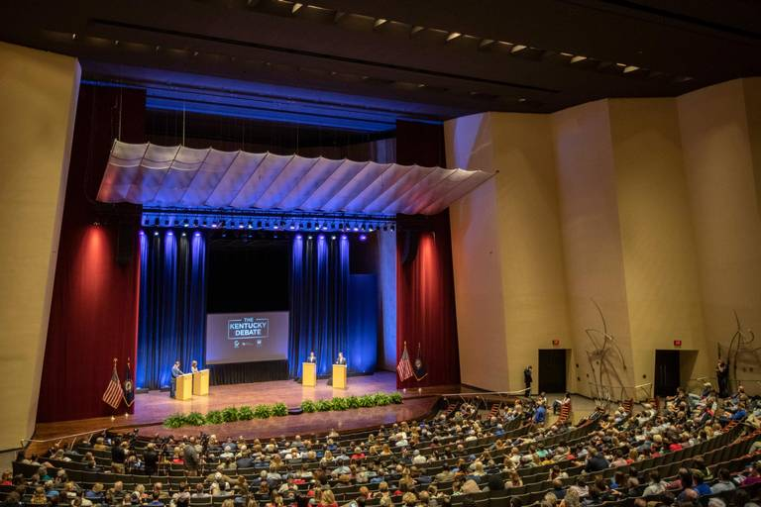
Ryan C. Hermens Kentucky Gov. Matt Bevin, Republican candidate for governor, left, and Kentucky Attorney General Andy Beshear, Democratic candidate for Kentucky governor, participate in a debate at the Singletary Center for the Arts on the University of Kentucky campus in Lexington, Ky., Tuesday, Oct. 15, 2019.

